**Assignment No: 10**

**Deploy a project from GitHub to EC2 by creating a new security group and user data.**

**Solution:**

**Step 1:** Upload required files to GitHub.

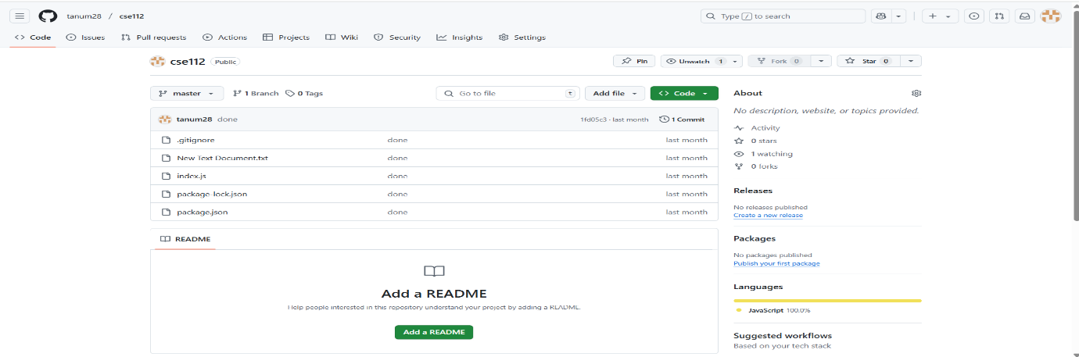

**Step 2:** Now open AWS and open the current instance then scroll down and go to security Section. Then click on the link in security groups then click on edit inbound rules.Click on add rule and select the type of new rule custom TCP Port range 4000 source 0.0.0.0 or anywhere then click on save rule.

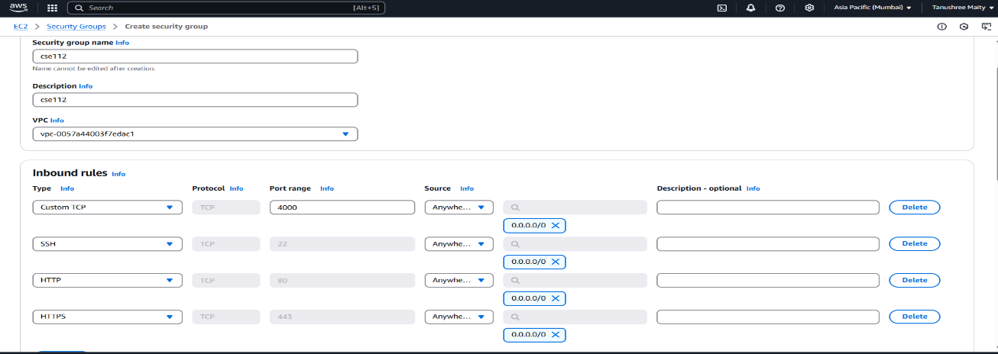

**Step 3:** open EC2 Click on launch instance. Give a name to the instance and select the operating system as Ubuntu.

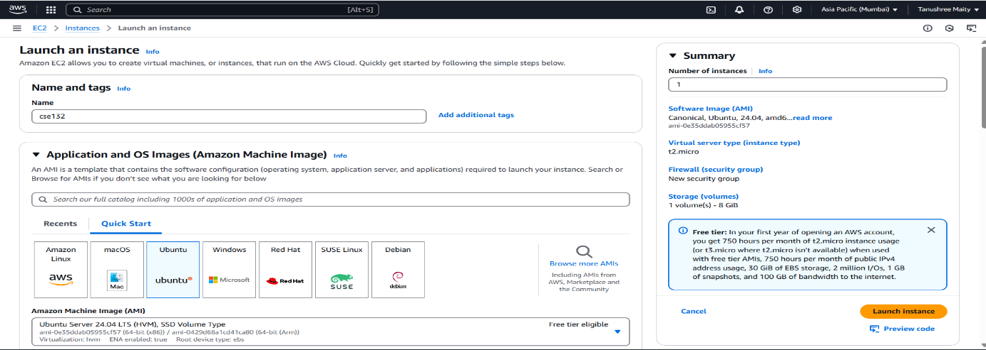

**Step 4:** Create Key Pair.

**Step 5:** From the Network Section Select Existing Security Group then choose your previously created security group.

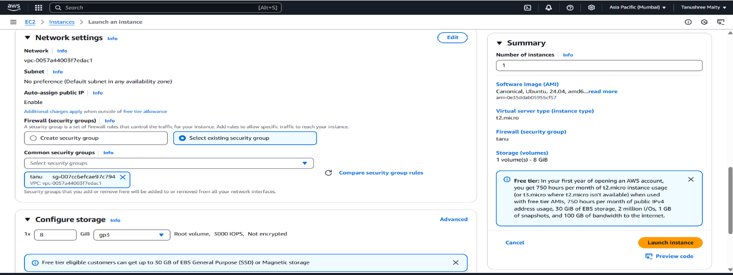

**Step 6:** After Selecting security group go to the user data section and write given cmd. and click launch instance.

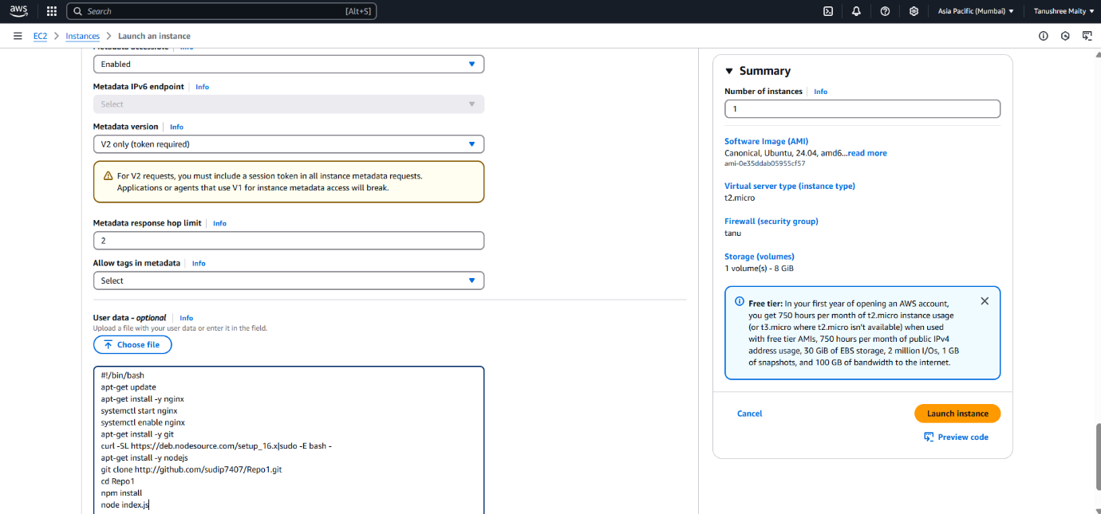

**Step 6:** Now copy the IPv4 address of the instance and paste it on web browser.

**Step 7:** Then, put the port like this IP address: Port (13.235.68.243:4000)

